**DB DIAGRAM**

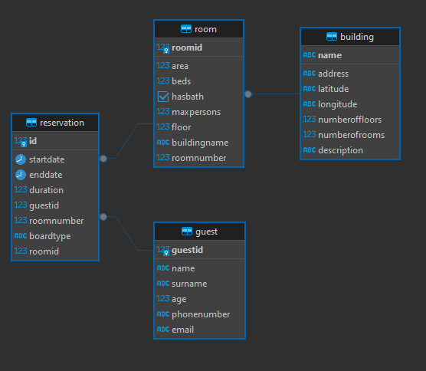

**CHECK CONSTRAINTS**

1) guest age check

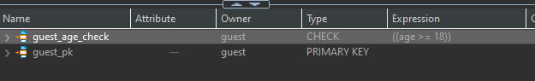

2) reservation boarding type check (has to be ‘BB’, ‘HB’ or ‘no’)

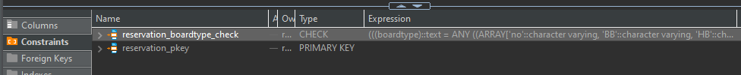

3) checks for positive values for number of floors and rooms:

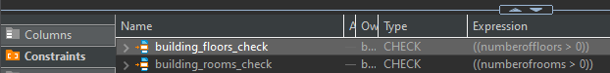

**RESERVATION TABLE**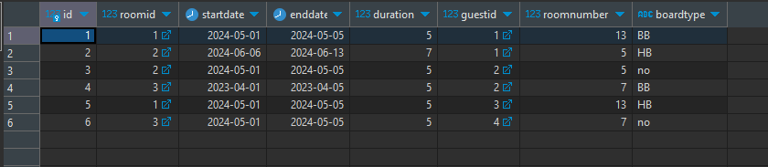

|  |  |  |  |  |  |
| --- | --- | --- | --- | --- | --- |
| **guest** |  |  |  |  |  |
| guestid | name | surname | age | phonenumber | email |
|  | Alex | Random | 23 | +45 34 255 66 72 | [a.ran@dom.com](mailto:a.ran@dom.com) |
|  | Tom | Soyer | 98 | +7 565 345 77 89 | [tom@soyer.kr](mailto:tom@soyer.kr) |
|  | Siri | Adams | 25 | +234 6587 | [hey@siri.us](mailto:hey@siri.us) |
|  | Taylor | Swift | 33 | +56 78765 | [tay@lor.com](mailto:tay@lor.com) |

|  |  |  |  |  |  |  |
| --- | --- | --- | --- | --- | --- | --- |
| **building** |  |  |  |  |  |  |
| address | name | latitude | longitude | numberoffloors | numberofrooms | description |
| Same str. | 1A | 1`232123 | 34634 | 10 | 40 | description 1 |
| Same str. | 1B | 2342 | 35353 | 11 | 44 | description 2 |

|  |  |  |  |  |  |  |  |
| --- | --- | --- | --- | --- | --- | --- | --- |
| **room** |  |  |  |  |  |  |  |
| area | beds | hasbath | maxpersons | floor | buildingname | roomnumber | roomid |
| 35 | 1 | false | 1 | 4 | 1A | 13 |  |
| 42 | 1 | true | 1 | 2 | 1B | 5 |  |
| 60 | 2 | true | 2 | 2 | 1A | 7 |  |

|  |  |  |  |  |  |  |  |
| --- | --- | --- | --- | --- | --- | --- | --- |
| **reservation** |  |  |  |  |  |  |  |
| id | startdate | enddate | duration | guestid | roomnumber | boardtype | roomid |
|  | 01.05.2024 | 05.05.2024 | 5 | 1 | 13 | BB | 1 |
|  | 06.06.2024 | 13.06.2024 | 7 | 1 | 5 | HB | 2 |
|  | 01.05.2024 | 05.05.2024 | 5 | 2 | 5 | no | 2 |
|  | 01.04.2023 | 05.04.2023 | 5 | 2 | 7 | BB | 3 |
|  | 01.05.2024 | 05.05.2024 | 5 | 3 | 13 | HB | 1 |
|  | 01.05.2024 | 05.05.2024 | 5 | 4 | 7 | no | 3 |